POWERS AND ROOTS
Pearson Edexcel - Thursday 4 June 2020 - Paper 2 (Calculator) Foundation Tier

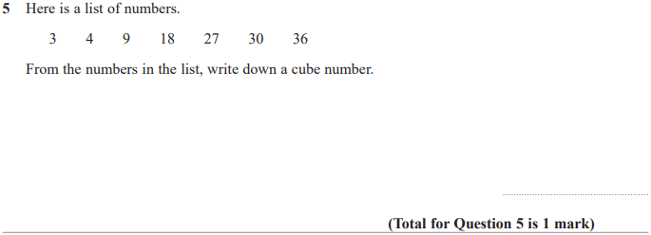

Pearson Edexcel - Monday 8 June 2020 - Paper 3 (Calculator) Foundation Tier

Pearson Edexcel - Tuesday 21 May 2019 - Paper 1 (Non-Calculator) Foundation Tier

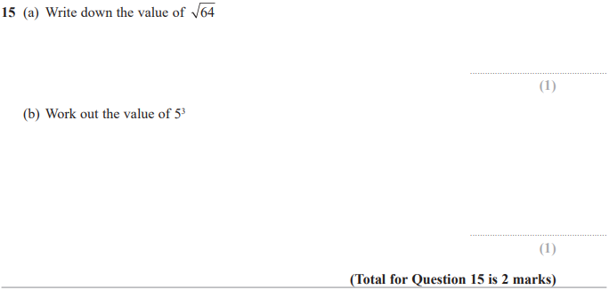

Pearson Edexcel - Tuesday 11 June 2019 - Paper 3 (Calculator) Foundation Tier

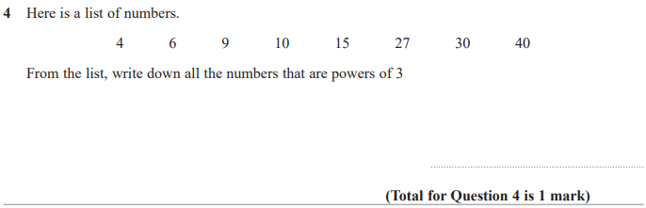

Pearson Edexcel - Thursday 8 November 2018 - Paper 2 (Calculator) Foundation Tier

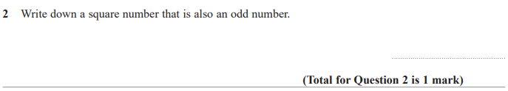

Pearson Edexcel - Monday 12 November 2018 - Paper 3 (Calculator) Foundation Tier

Pearson Edexcel - Thursday 7 June 2018 - Paper 2 (Calculator) Foundation Tier

Pearson Edexcel - Tuesday 12 June 2018 - Paper 3 (Calculator) Foundation Tier

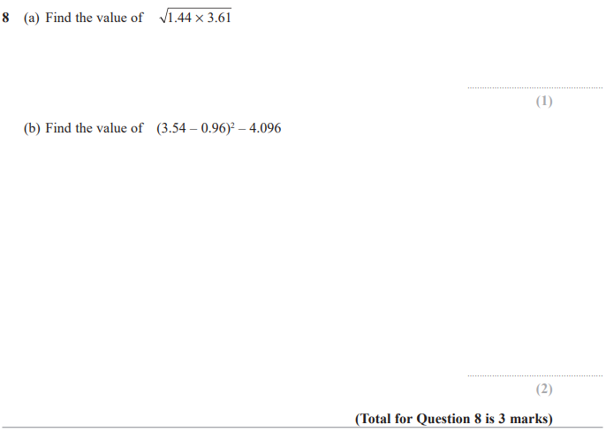

Pearson Edexcel – Specimen 2 - Paper 1 (Non-Calculator) Foundation Tier

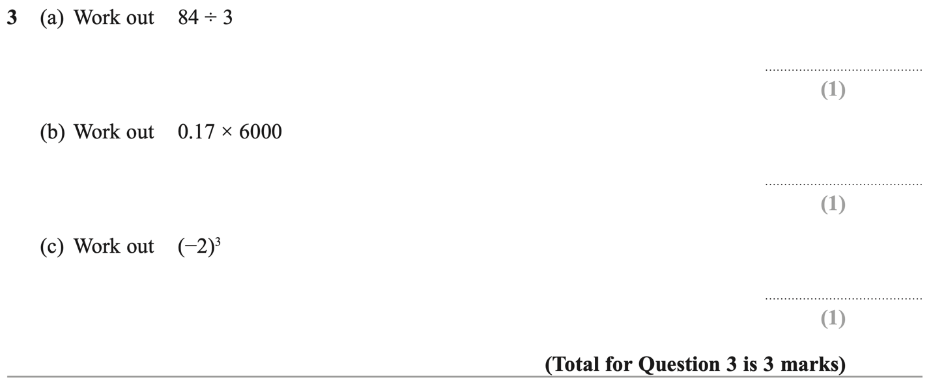

Pearson Edexcel – Specimen 2 - Paper 2 (Calculator) Foundation Tier

Pearson Edexcel – Specimen 2 - Paper 3 (Calculator) Foundation Tier

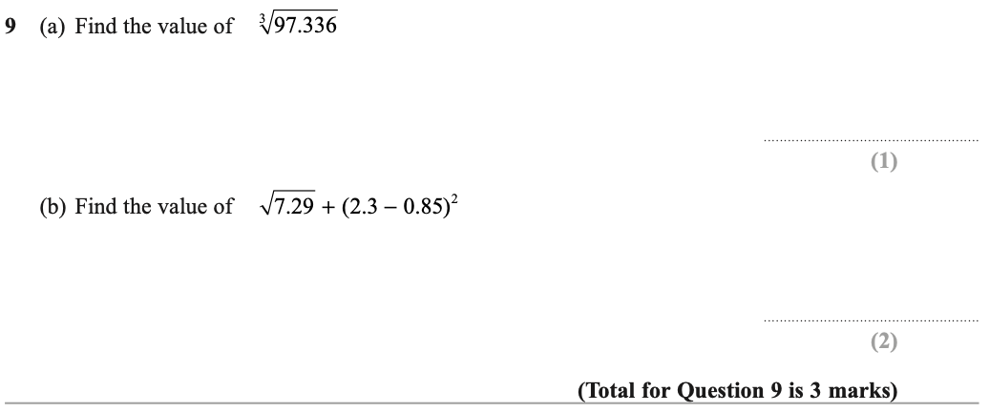

Pearson Edexcel – Specimen 1 - Paper 1 (Non-Calculator) Foundation Tier

Pearson Edexcel – Specimen 1 - Paper 2 (Calculator) Foundation Tier
- 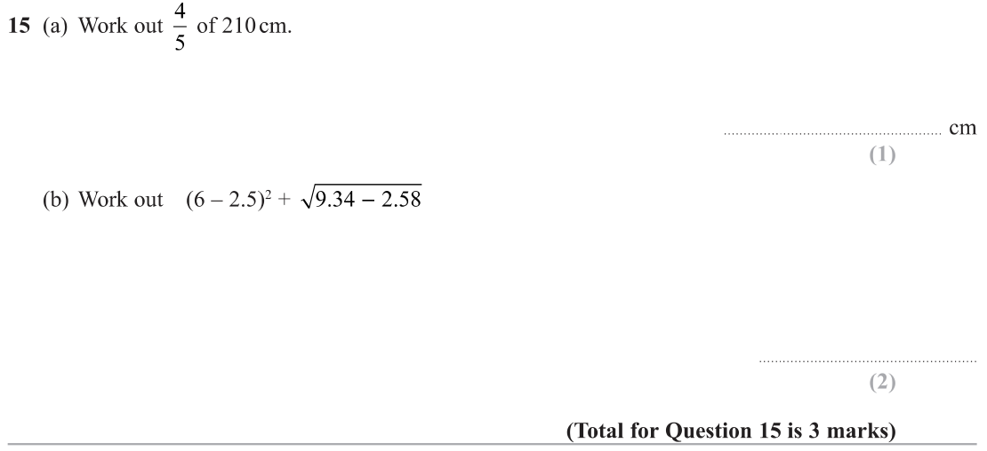

Pearson Edexcel – Specimen 1 - Paper 3 (Calculator) Foundation Tier

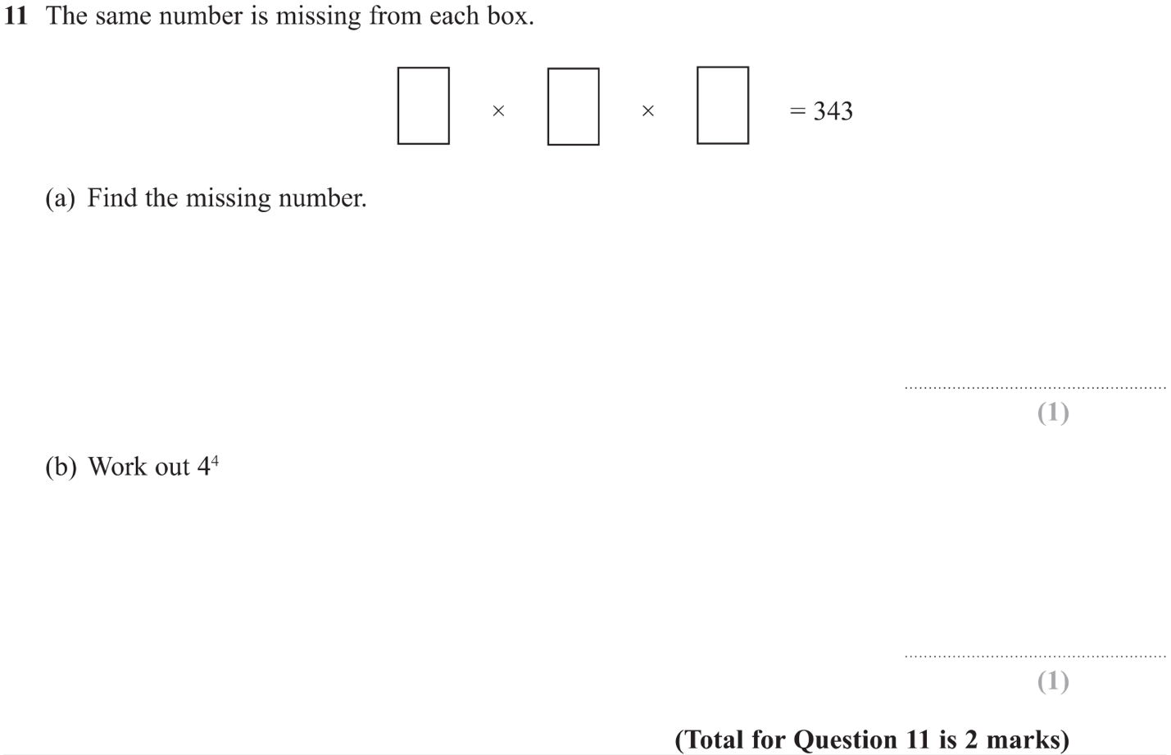

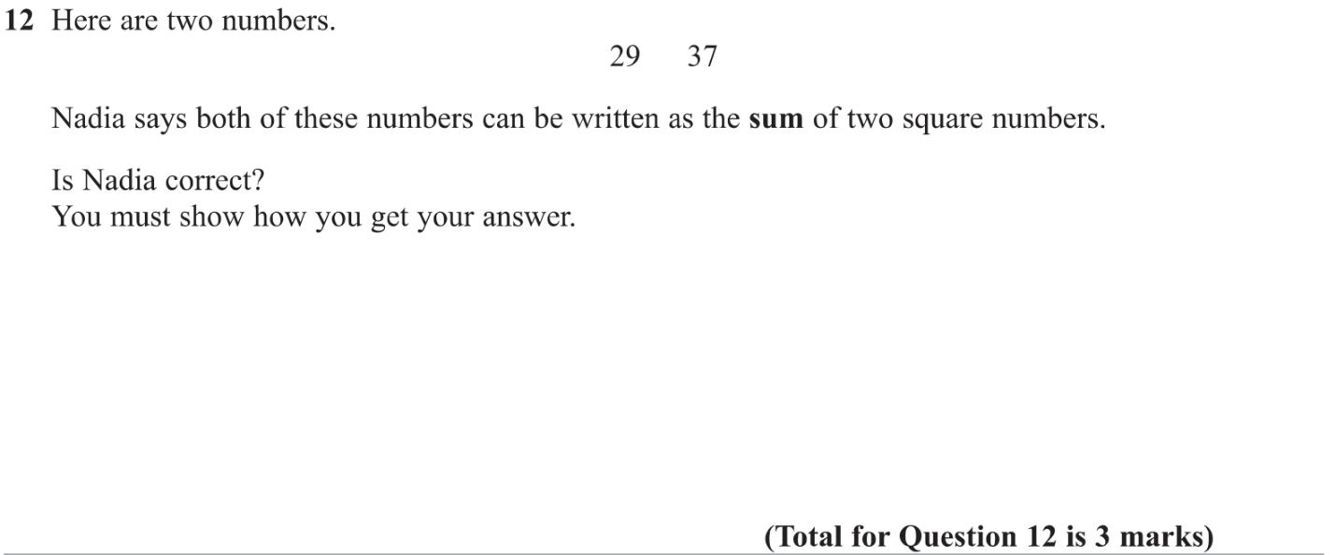

OCR – Tuesday 03 November 2020- Morning - Paper 1 (Calculator) Foundation Tier
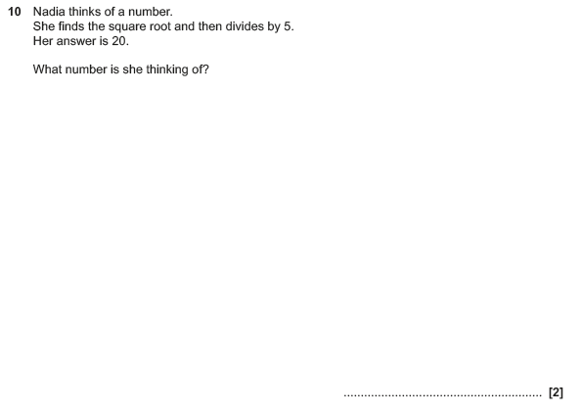

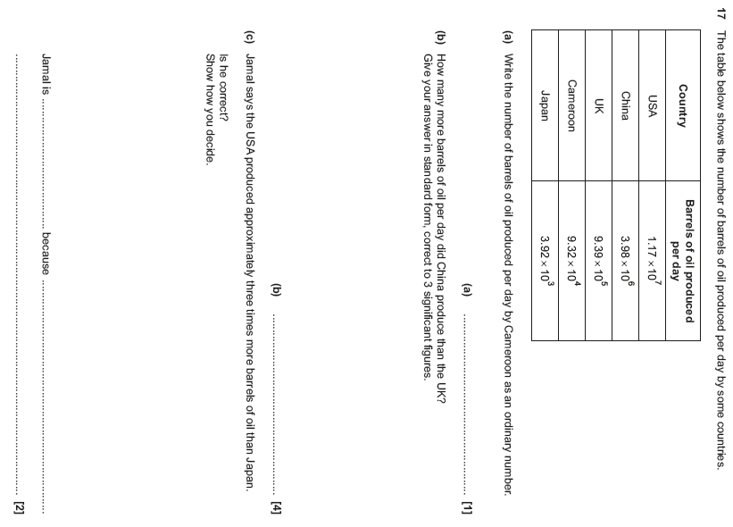

OCR Thursday 05 November 2020- Morning (Non-Calculator) Foundation Tier
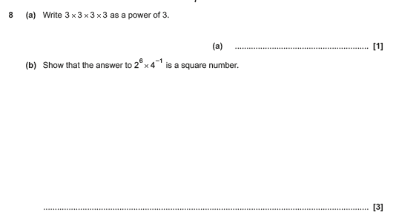

OCR November 09 November 2020- Morning (Calculator) Foundation Tier
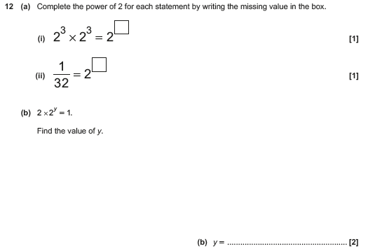

OCR Thursday 07 November 2019- Morning (Non-Calculator) Foundation Tier
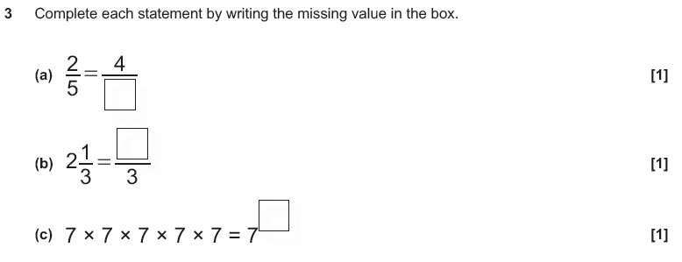

OCR Monday 11 November 2019 – Afternoon (Calculator) Foundation Tier
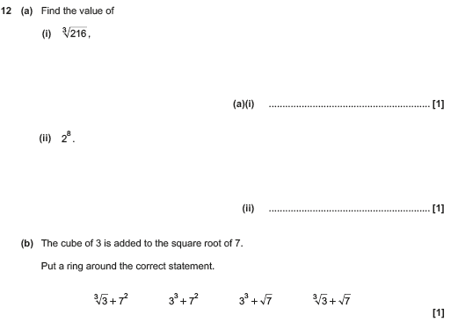

OCR Tuesday 21 May 2019 – Morning (Calculator) Foundation Tier
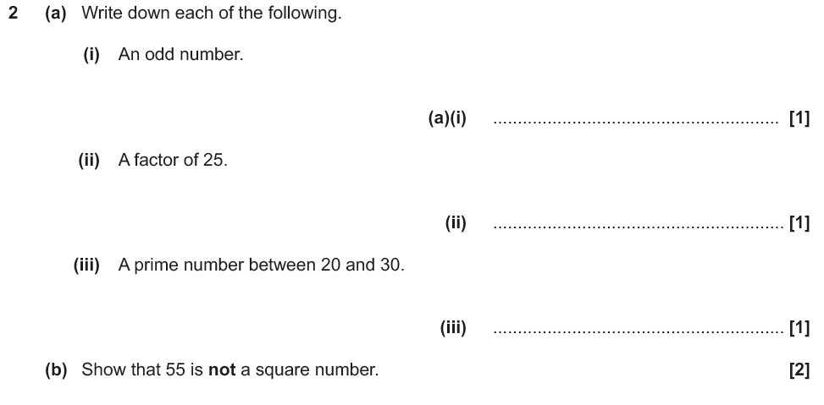

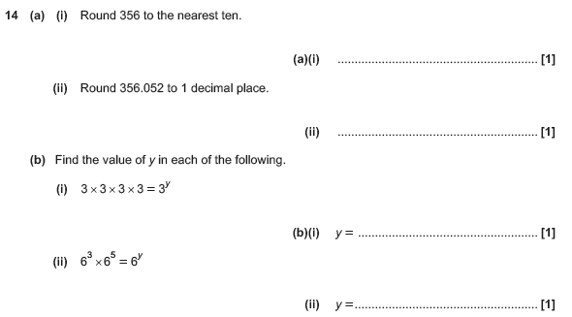

OCR Thursday 6 June 2019 – Morning (Non-Calculator) Foundation Tier
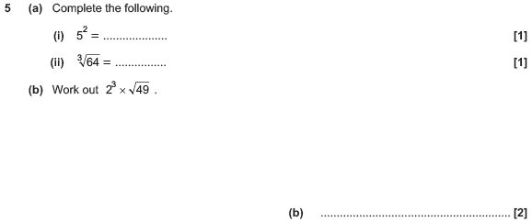

OCR Tuesday 6 November 2018 – Morning (Calculator) Foundation Tier

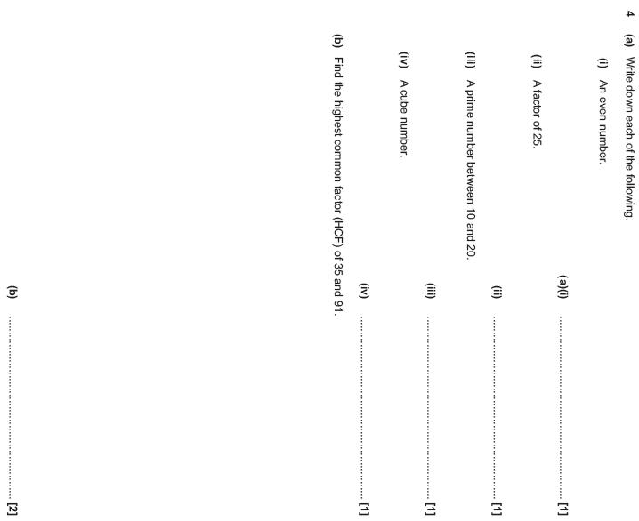

OCR Thursday 8 November 2018 – Morning (Non-Calculator) Foundation Tier
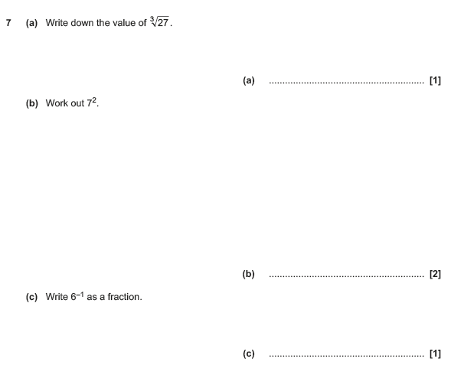

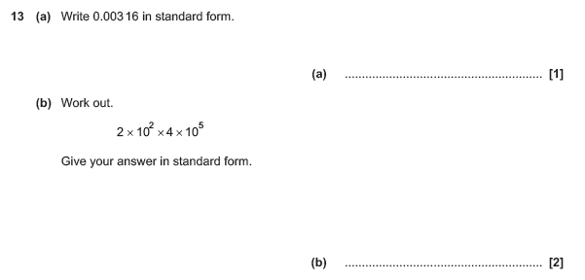

OCR Monday 12 November 2018 – Morning (Calculator) Foundation Tier
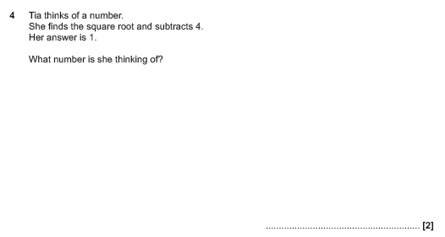

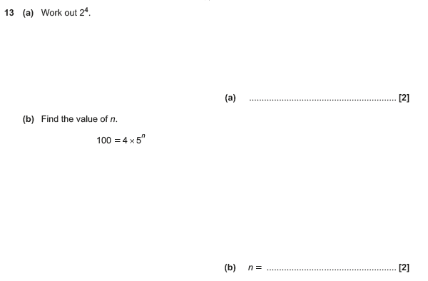

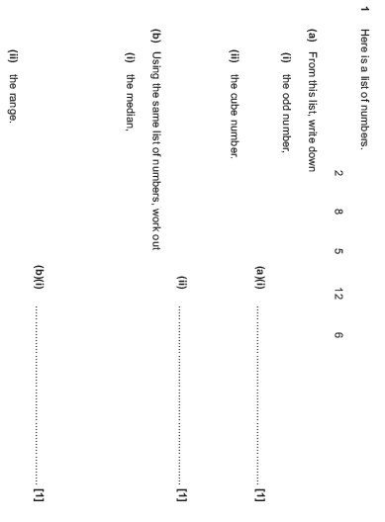
OCR Monday 24 May 2018 – Morning (Calculator) Foundation Tier

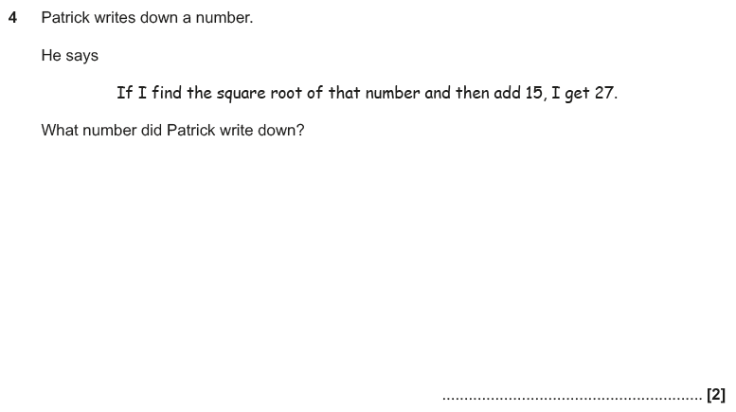

OCR Thursday 7 June 2018 – Morning (Non Calculator) Foundation Tier
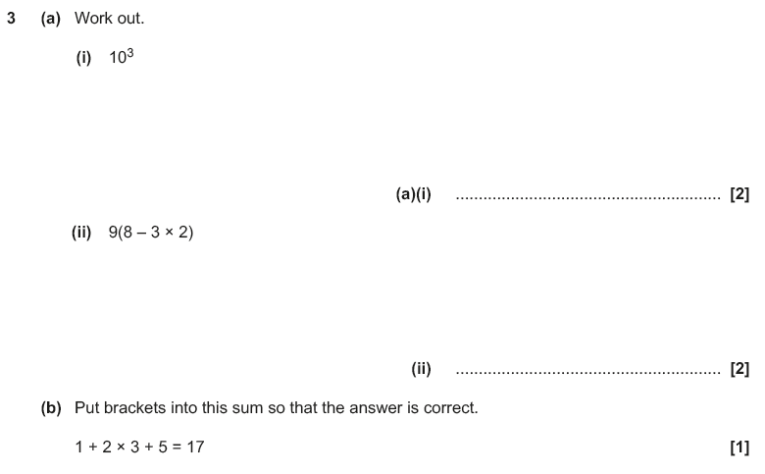

OCR Tuesday 12 June 2018– Morning (Calculator) Foundation Tier
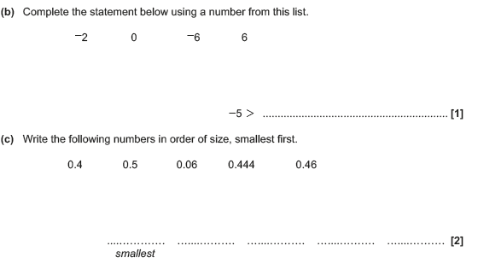
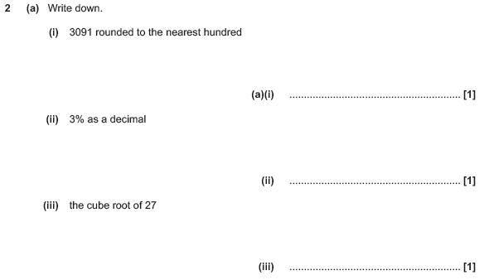

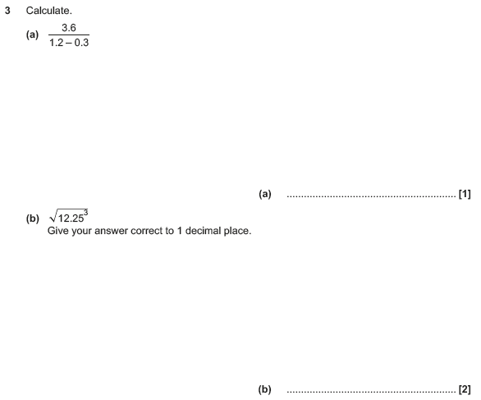

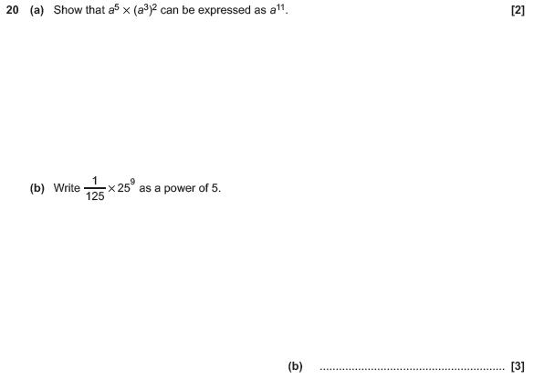

OCR Thursday 2 November 2017– Morning (Calculator) Foundation Tier
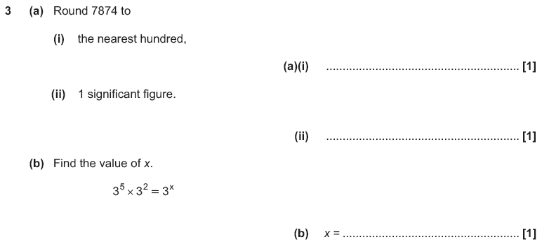

OCR Monday 6 November 2017– Morning (Calculator) Foundation Tier

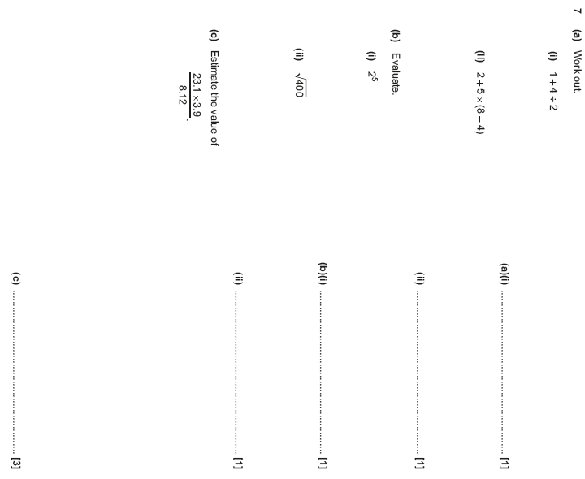

OCR Monday 6 November 2017– Morning (Calculator) Foundation Tier
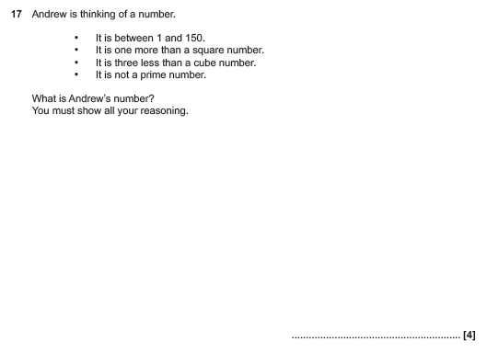

Pearson Edexcel –Sample Papers - Paper 2 (Calculator) Foundation Tier

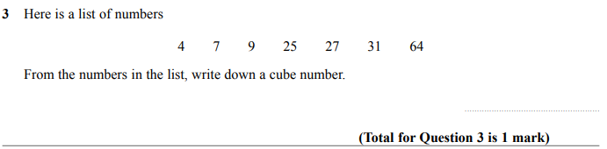

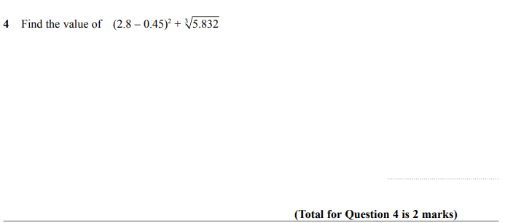

OCR Wednesday 8 November 2017– Morning (Calculator) Foundation Tier

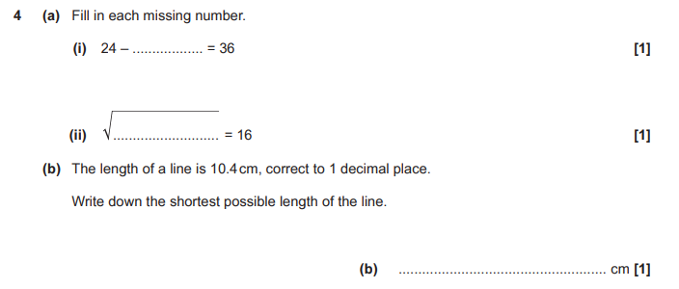

OCR Thursday 8 June 2017 – Morning (Non - Calculator) Foundation Tier

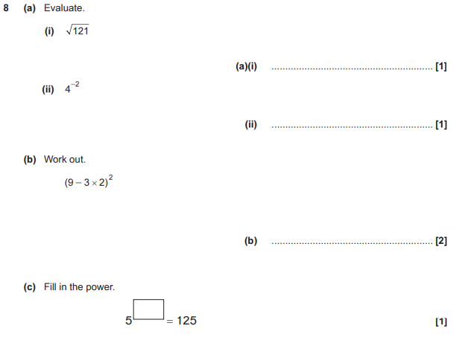

OCR Sample Question Paper 3 – Morning/Afternoon (Calculator) Foundation Tier

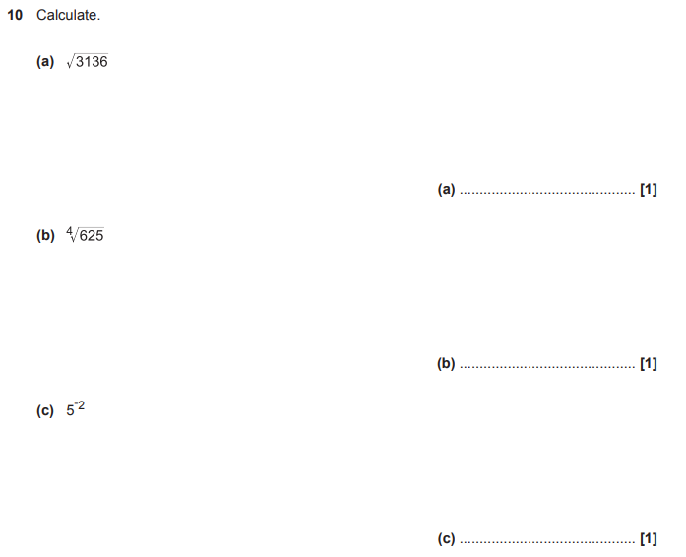

AQA Thursday 4 June 2020 – Morning (Calculator) Foundation Tier

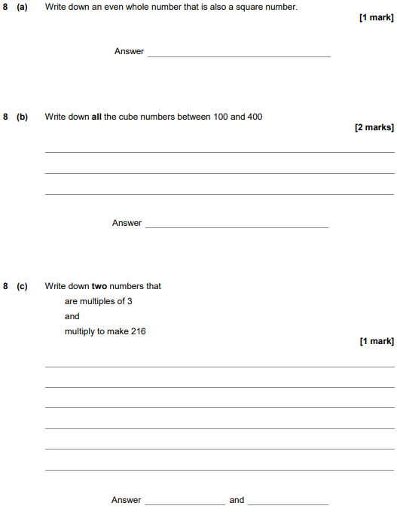

AQA Thursday 6 June 2019 – Morning (Calculator) Foundation Tier

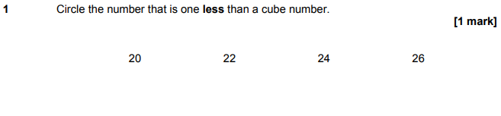

AQA Thursday 11 June 2019 – Morning (Calculator) Foundation Tier

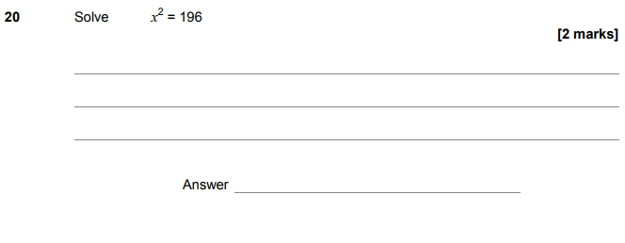

AQA Tuesday 6 November 2018 – Morning (Non-Calculator) Foundation Tier

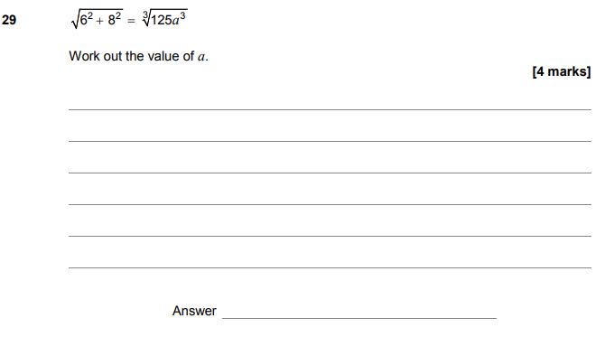
AQA Monday 12 November 2018 – Morning (Calculator) Foundation Tier

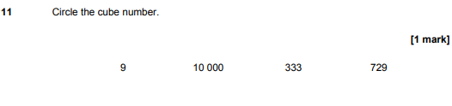
AQA Thursday 7 June 2018 – Morning (Calculator) Foundation Tier

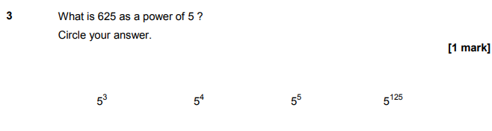
AQA Thursday 7 June 2018 – Morning (Calculator) Foundation Tier

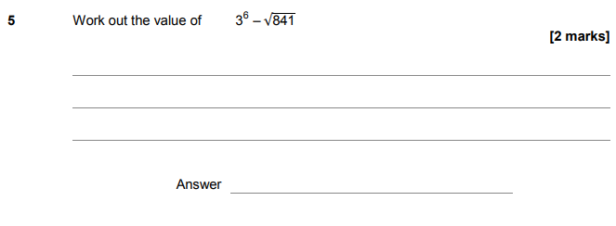

AQA Thursday 2 November 2017 – Morning (Non-Calculator) Foundation Tier

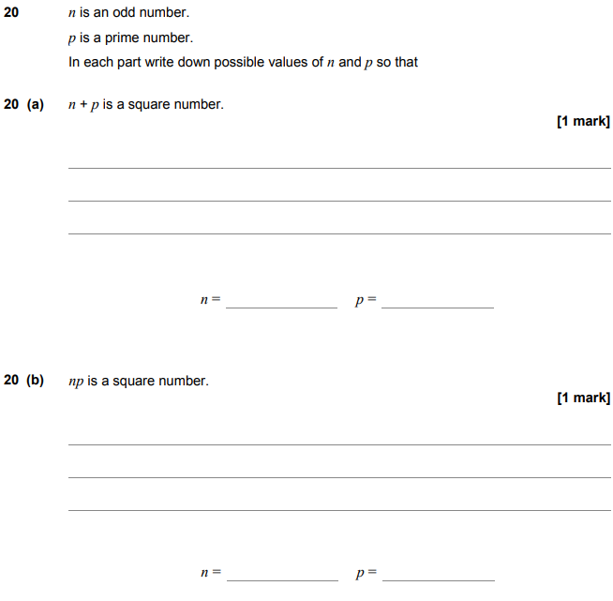

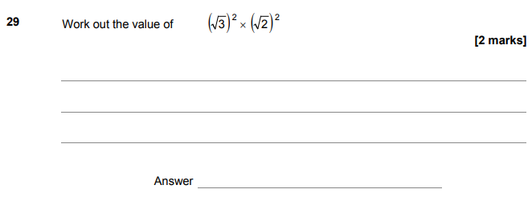
AQA Monday 6 November 2017 – Morning (Calculator) Foundation Tier

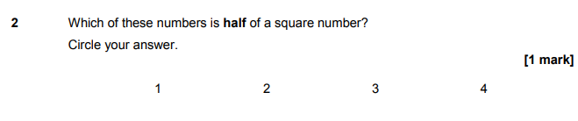

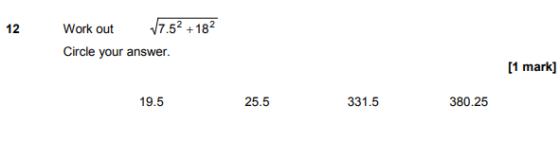

AQA Wednesday 8 November 2017 – Morning (Calculator) Foundation Tier

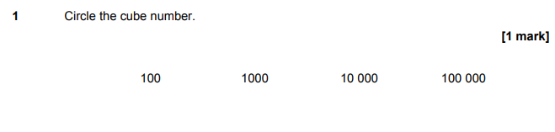
AQA Wednesday 8 November 2017 – Morning (Calculator) Foundation Tier

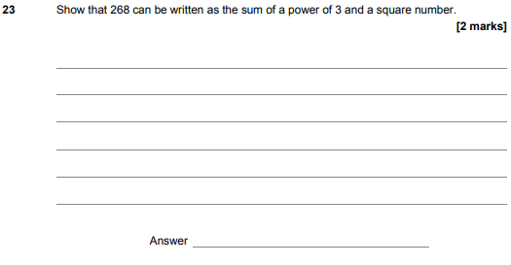
AQA Tuesday 13 June 2017 Morning– Morning (Calculator) Foundation Tier

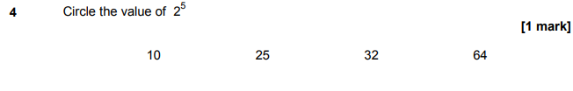

AQA Sample Paper 3– Morning (Calculator) Foundation Tier

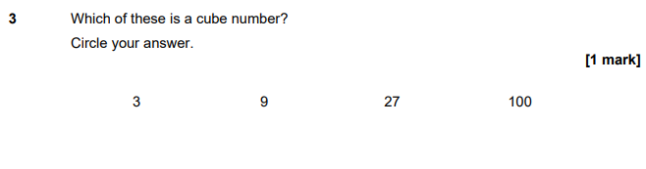
AQA Sample Paper 3– Morning (Calculator) Foundation Tier

